|  |  |  |
| --- | --- | --- |
| Name: | | |
| Assessment Task | | |
| ATAR Physics Unit 4 | | |
| **Task 9: Relativity, Standard Model and Big Bang Theory** | | |
| TASK DATE: 5/09/2024 | | |
| Task Details | | |
| Science Understanding | | |
| Weighting: 10 % | | |
| Time Allowed: 55 minutes | | |
| Content Description | | |
| * the Big Bang theory explains the expansion of space, which is measured by redshift and is supported by Hubble’s law. This includes applying the relationship: $v= H_{0}d$* the Standard Model is used to describe the evolution of forces and the creation of matter in the Big Bang theory * high-energy particle accelerators use electric and magnetic fields to accelerate particles.   This includes deriving, understanding, and applying the relationship:   * the special theory of relativity is based on two postulates: that the speed of light in a vacuum is an absolute constant, and that all inertial reference frames are equivalent. * motion can only be measured relative to an observer; length and time are relative quantities that depend on the observer’s frame of reference.   This includes applying the relationships: $l = l_{0} \sqrt{\left(1-\frac{v^{2}}{c^{2}}\right)}$ $t = \frac{t_{0}}{\sqrt{\left(1- \frac{v^{2}}{c^{2}}\right)}}$   * relativistic momentum increases at high relative speed and prevents an object from reaching the speed of light   This includes applying the relationship: $$p_{v = \frac{m v}{\sqrt{\left(1-\frac{v^{2}}{c^{2}}\right)}}}$$  * the concept of mass-energy equivalence emerged from the special theory of relativity and explains the source of the energy produced in nuclear reactions. The mass of an object is constant and independent of its motion   This includes applying the relationship: $$E_{t}= \frac{mc^{2}}{\sqrt{1- \frac{v^{2}}{c^{2}}}}$$ | | |
| **Task Preparation** | | |
| The Standard Model, Special Relativity and the Big Bang Theory | | |
| **Test conditions** | | |
| * Individual work * Final answers should be given up to three significant figures and include appropriate units where appropriate. Questions containing the instruction "ESTIMATE" should be given two significant figures and include appropriate units where applicable. * Scientific Calculators are allowed. * No notes allowed. * Formula sheet is provided. | | |
| Standard test items | | |
| **Submission** | | |
| * This question-and-answer booklet * Data Sheet | | |
| **Achievement** | | |
| _________/51  __________% | Teacher Signature |  |

|  |  |  |  |  |
| --- | --- | --- | --- | --- |
| **Section** | Number of questions | Your Mark | Marks available | Percentage of Test |
| Short Answers | 5 |  | 22 | 43 |
| Problem solving | 2 |  | 20 | 39 |
| Comprehension | 1 |  | 9 | 18 |
|  | **Total** |  | **51** | **100** |

**Section One:** **Short answer**

**Question 1 (2 marks)**

An exotic hadron, initially seen over 40 years ago, has recently been confirmed at the European Organisation for Nuclear Research (CERN). The Z(4430) is a composite consisting of 4 quarks, a charm, an anti-charm, a down and an anti-up.

Show the calculation required and determine the charge of the Z(4430) particle.

**_____________________ e**

**Question 2 (5 marks)**

The following graph shows the factor by which mass increases with increasing velocity approaching the speed of light.

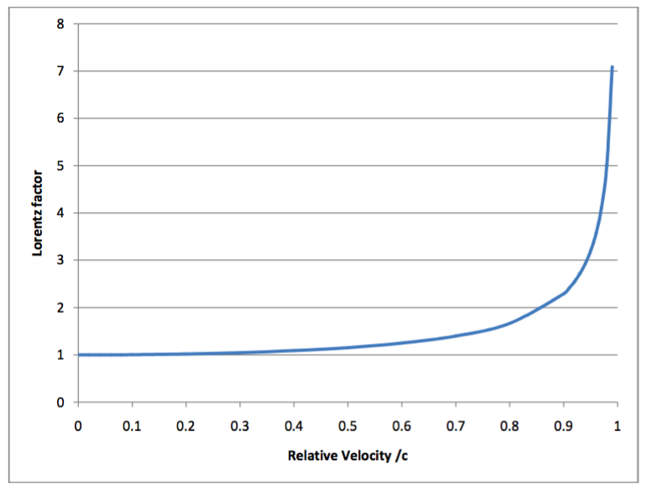

A proton of mass 1.67 x 10-27 kg is accelerated in the Large Hadron Collider until it reaches 0.95*c*   
(*c* = speed of light).

1. Estimate the new mass of the proton from the graph. (2 marks)
2. What is the reason for this apparent increase in mass? (1 mark)

______________________________________________________________________________________________________________________________________________________________________________________

Einstein derived the mathematical equation showing how mass changes with speed.



where m0 is the rest mass and mv is the mass when moving (in kg).

1. Using the equation above, calculate the mass of the proton when it is moving at 0.99*c*. (2 marks)

**Question 3 (4 marks)**Muons are subatomic particles that were discovered in 1936 by researchers studying cosmic radiation. Most naturally-occurring muons are created when cosmic rays collide with atoms in the upper atmosphere, approximately 10 km above the Earth. A muon has a rest mass of 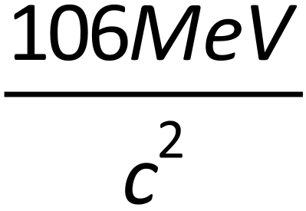 , a charge of -1 and an average lifetime of 2.2 × 10-6 s.

1. Muons travel at almost the speed of light. Calculate the average distance that a muon created in the upper atmosphere would travel before it decayed. Assume that its speed is equal to c and that there are no relativistic effects. (2 marks)

____________m

*Muons created by cosmic rays in the upper atmosphere can be detected by detectors on the Earth’s surface. This means that the muons have travelled much further than expected. An explanation of this phenomenon involves the effects of relativity.*

1. Explain how relativity affects the muons and enables them to travel over a greater distance than that calculated in part (a). (2 marks)

________________________________________________________________________________________________________________________________________________________________________________________________________________________________________________________________________________________________________________________________________________________________

**Question 4 (5 marks)**

Hubble’s law can be used to estimate the maximum size of the observable Universe. The graph below indicates the relationship between recessional speed of a star (or galaxy) and the distance to that star (or galaxy).

Distances are given in megaparsecs (Mpc) where 1 Mpc = 3.26 light years

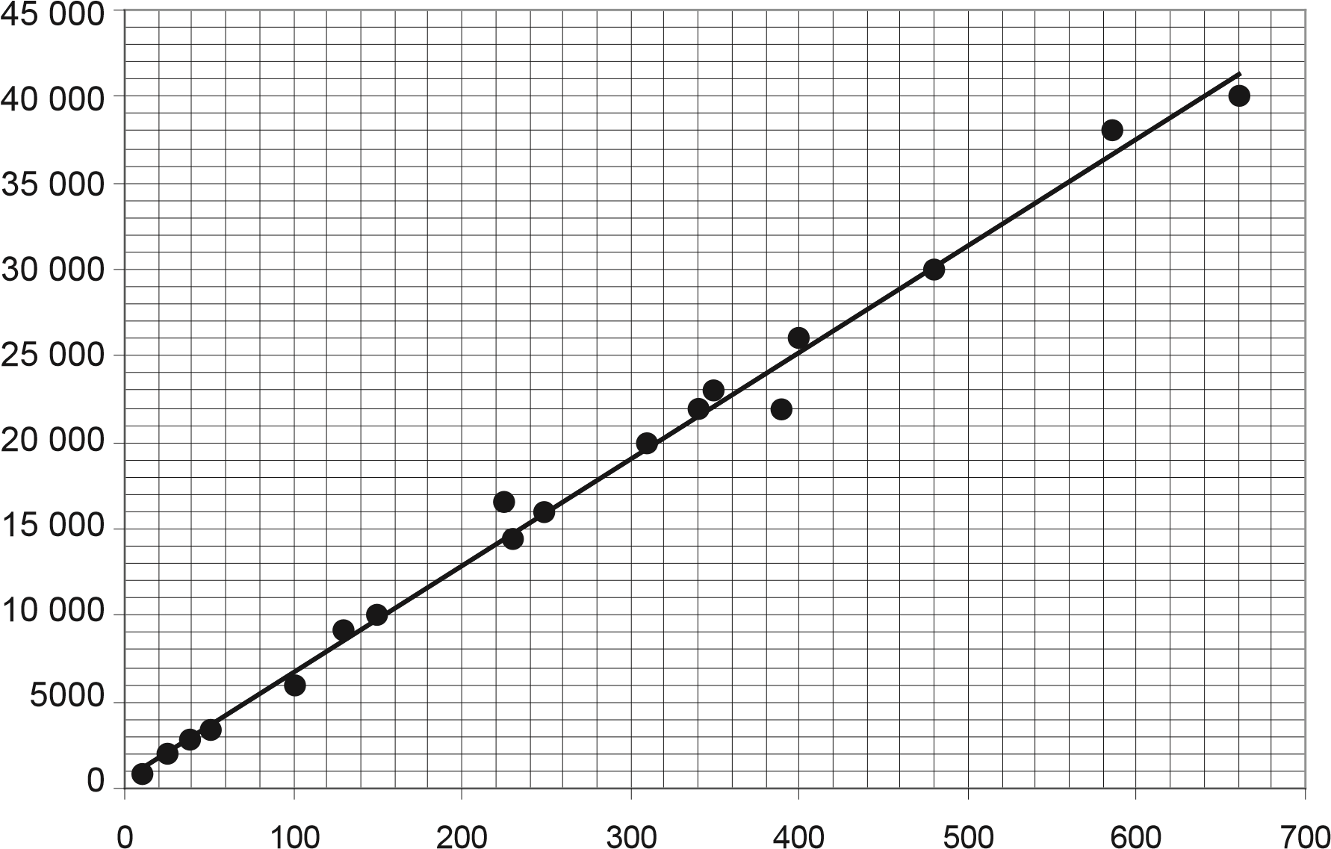

**Redshift (km s**

**–1**

**)**

1. The vertical axis is labelled ‘redshift’ with units for velocity (km s-1). Explain briefly the

relationship between redshift and the speed of the object. (2 marks)

1. Use the gradient of the graph to extrapolate a value for the maximum distance, in Mpc, for a galaxy to be observed from the Earth. Show **all** workings. (3 marks)

**Question 5 (6 marks)**

Under certain circumstances it is possible for a photon to be converted into an electron and a positron.

1. A photon must have a minimum energy in order to create an electron and a positron. Calculate the minimum energy of the photon in joules. Give your answer to an appropriate number of significant figures. (3 marks)
2. A photon of slightly higher energy than that calculated in part (b) is converted into an electron and a positron. State what happens to the excess energy. (1 mark)

_____________________________________________________________________________________

1. Describe what is likely to happen to the positron shortly after its creation. (2 marks)

________________________________________________________________________________________________________________________________________________________________________________________________________________________________________________________________________________________________________________________________________________________________

**Section Two: Problem Solving**

**Question 6 (12 marks)**

A group of astronauts is sent on a mission to collect data about an exoplanet that could possibly sustain human life. The spacecraft travels at a constant speed of 0.850c.

Two identical clocks that have been synchronised carefully on the Earth are to be used during the mission. One clock is left with an observer on Earth and the other is placed on the spacecraft. In the Earth’s frame of reference, the clocks are observed to tick once every second.

1. How much time, in seconds, would pass between ticks of the clock on the moving spacecraft in the spacecraft’s reference frame? (1 mark)

______________ s

1. How much time will an observer on Earth record on their clocks for the ticks of the clock on the spacecraft. (2 marks)

______________s

1. Explain why the values in (a) and (b) are different. (3 marks)

__________________________________________________________________________________________________________________________________________________________________________________________________________________________________________________________________________________________________________________________________________________________________________________________________________________________________________________________________________________________________________________________________________________________________

When measured on the Earth, the spacecraft is 119 m in length.

1. Calculate the length of the moving spacecraft, in metres, as measured by an observer in the Earth’s frame of reference. (2 marks)

____________m

1. Would the Earth observer notice any change in the height or width of the spacecraft? Explain your

answer. (2 marks)   
  
_______________________________________________________________________________________________________________________________________________________________________________________________________________________________________________________________________________________________________________________________________________________________________________________________________________________________________________________________________

A rocket probe is launched forward from the spacecraft. The rocket probe moves at 0.500c relative to the spacecraft.

1. To an observer in the Earth’s frame of reference, what would be the speed of the rocket probe in m s-1? (2 marks)

**Question 7 (8 marks)**

A particular baryon consists of two up quarks and a strange quark.  
  
a) Determine the spin, charge and baryon number for this baryon (3 marks)

Spin _________

Charge _________

Baryon number _____________

b) A neutron will decay into a proton and an electron as shown in the equation below.  
  
  
 n 🡪 p+ + e- + ?

1. Demonstrate that the baryon number is preserved in the way that the equation is written  
    (1 mark)
2. Demonstrate that the lepton number is not conserved. (1 mark)
3. Identify the third particle in the decay to ensure that the lepton number is conserved. (1 mark)

c) Identify **one** type of gauge boson and describe its role in the nucleus (2 marks)

**Section Three: Comprehension and data analysis (9 marks)**

**Question 8**

The Doppler shift in the wavelength of light emitted by galaxies can be used to measure the speed with which they are moving towards or away from the Earth.

Like the Sun, galaxies emit a wide range of wavelengths. The analysis of the absorption spectra of light from galaxies can have two spectral lines missing due to the absorption by calcium ions as light passes through the gases surrounding galaxies.

In the constellation Eridanus which is visible in the western sky between January to April there is a spiral galaxy NGC 1357. The wavelength of one of the calcium absorption lines in the spectrum from NGC 1357 is 399.72 nm. The same line in the calcium spectrum measured in a laboratory on Earth is 396.85 nm.

1. Is the spiral galaxy NGC 1357 moving towards or away from the Earth?

(1 mark)

1. Justify your answer to (a) using a brief explanation and a diagram.

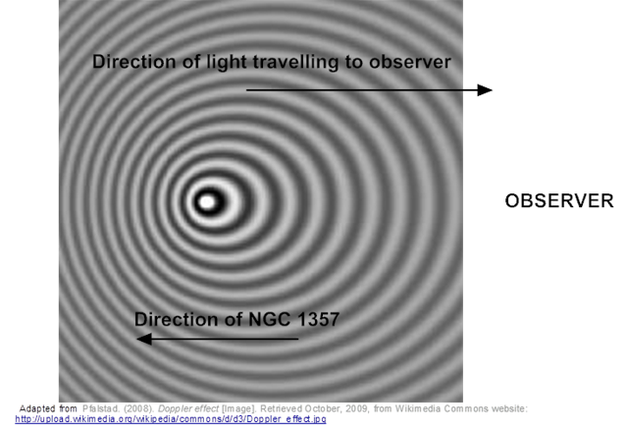

(4 marks)

________________________________________________________________________  
  
________________________________________________________________________

________________________________________________________________________  
  
________________________________________________________________________

________________________________________________________________________  
  
________________________________________________________________________

________________________________________________________________________  
  
________________________________________________________________________

Calculate the velocity of NGC 1357 using the relationship $\frac{∆λ}{λ_{rest}}=\frac{v}{c}$

Where $Δλ=λ_{shifted}-λ_{rest}$ and λrest is the wavelength of the fixed source, v is the speed of the moving source and c is the speed of light. (2 marks)  
  
  
  
  
  
  
  
  
  
  
  
  
  
  
  
  
  
_________________m s-1

1. A star has a recessional velocity of 58.9 km s-1. Calculate the ‘red shift’ that would be expected in the calcium 396.849 nm absorption line from this star.

Use the relationship

$$\frac{∆λ}{λ_{rest}}=\frac{v}{c}$$

Where, Δλ is the change in wavelength, λrest is the wavelength of the fixed source, v is the speed of the moving source and c is the speed of light.

(2 marks)

___________________ m

**End of Test**